Missionaries and Cannibals Problem
AIM:
To implement a Python program for solving the Missionaries and Cannibals Problem using the state-space search method.
ALGORITHM
- Start with 3 missionaries and 3 cannibals on the left side of the river.
- The boat can carry a maximum of 2 people.
- Move one or two people from one side to the other.
- After every move, check that missionaries are not outnumbered by cannibals on either side.
- If a state is valid, continue to the next state.
- Repeat the process until all missionaries and cannibals reach the right side.
- Display the solution path.
PROCEDURE
- Initialize the starting state as (3, 3, 0, 0, 0).
- Generate all possible boat movements.
- Check whether each new state is valid.
- Use Breadth First Search (BFS) to find the shortest solution.
- Display the sequence of states from the initial state to the goal state.
PROGRAM
from collections import deque

def valid(m1, c1, m2, c2):
if m1 < 0 or c1 < 0 or m2 < 0 or c2 < 0:
return False

if m1 > 0 and m1 < c1:
return False

if m2 > 0 and m2 < c2:
return False

return True

def solve():
start = (3, 3, 0, 0, 0)
goal = (0, 0, 3, 3, 1)

moves = [(1, 0), (0, 1), (2, 0),
(0, 2), (1, 1)]

queue = deque([(start, [start])])
visited = {start}

while queue:
state, path = queue.popleft()

m1, c1, m2, c2, boat = state

if state == goal:
for s in path:
print(s)
return

for m, c in moves:
if boat == 0:
new_state = (m1-m, c1-c, m2+m, c2+c, 1)
else:
new_state = (m1+m, c1+c, m2-m, c2-c, 0)

if valid(*new_state[:4]) and new_state not in visited:
visited.add(new_state)
queue.append((new_state, path + [new_state]))

solve()
OUTPUT
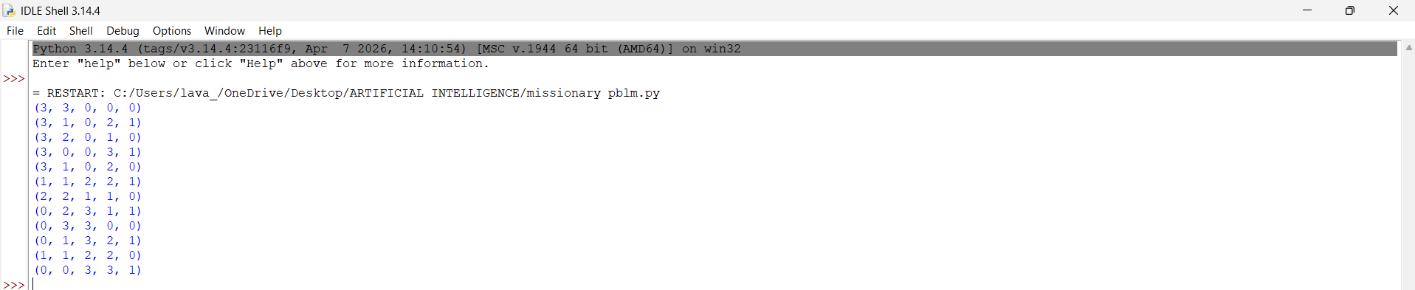State format: (Missionaries Left, Cannibals Left, Missionaries Right, Cannibals Right, Boat Side)
RESULT
Thus, the Missionaries and Cannibals Problem was implemented successfully using Python and Breadth First Search (BFS).

